J.J. College of Arts and Science (Autonomous)
Re-Accredited by NAAC with “A” Grade in 3rd Cycle
Affiliated to Bharathidasan University – Tiruchirappalli
J.J. Nagar, Sivapuram Post, Pudukkottai – 622 422
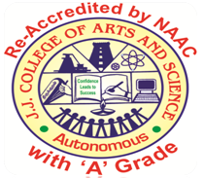

CURRICULUM DESIGN PROCESS

